Voulmes inforation:

Image1

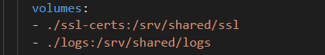

Above setup is from shrivatsa’s vs code

Image2

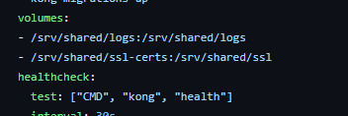

Iimage 2 is from github team kong. So image has setup /srv/shared/logs:/srv/shared/logs

Here left side part is folder strucure of kong and they need to logs file to /srv/shared/ in right side.

I

Image1 ./logs:/srv/shared/logs logs folder is there in the same folder structure so we need to add ./logs in left side. Then in right side u need to add /srv/shared this is there in kong file so we need to pass logs file to kong folder structure so for these reason you need send logs in right hand side as /srv/shared/logs.

./ssl-certs is there in same folder structure then you need to add it as ./ssl-certs.

So we need to pass these file to kong folder structure so send this in righthand side as /srv/shared/sll-certs.